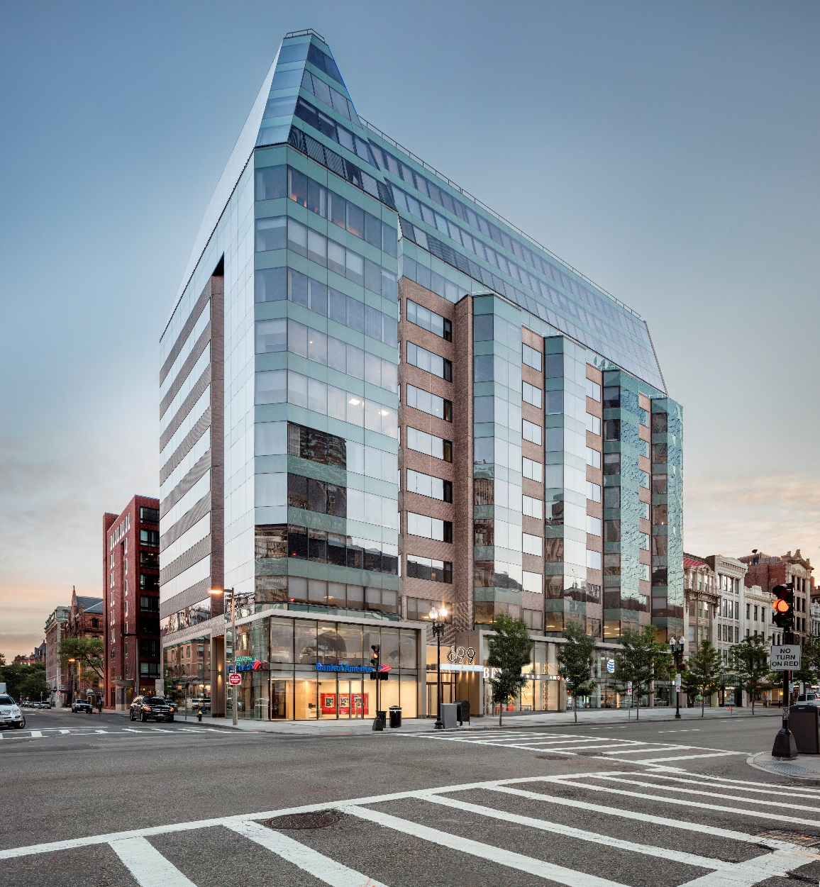

699 BOYLSTON STREET

TENANT HANDBOOK

Updated 1/19

Owner: CPT One Exeter Plaza, LLC

Managed by: Cushman & Wakefield of Massachusetts, Inc.

TABLE OF CONTENTS

Section 1: Property Management and Leasing

1.1 Property Management Company
1.2 Property Leasing Company

Section 2: Emergency Contact Information

Section 3: Rent Payments

Section 4: Business Hours

Section 5: Security Personnel

Section 6: Building Access

6.1 Operating Hours for Front Entry Doors
6.2 Access Cards
6.3 Angus Anywhere
A. Work Orders
B. Visitor Access Management System
6.4 Tenant Access – After-Hours without Access Card but Valid Photo ID
6.5 Tenant Access – After-Hours without Access Card or Photo ID
6.6 Office Space Access Request
6.7 After-Hours Access for Visitors
6.8 Vendor & Contractor Access
6.9 Food Deliveries
6.10 Package Deliveries

Section 7: Certificates of Insurance

7.1 Tenant’s Insurance Coverage
7.2 Contractors, Subcontractors, and Service Vendor’s Insurance

Section 8: Sustainable Building Operations

8.1 Energy and Carbon Reduction Measures
8.2 Adherence to Landlord’s Sustainability Practices
8.3 Recycling and Waste Management

Section 9: Signage

Section 10: Tenant Moves/Deliveries

10.1 Deliveries and Elevator Schedules
10.2 Loading Dock

Section 11: Keys and Locksets

TABLE OF CONTENTS (continued)

Section 12: Rules and Regulations per Tenant Leases

Section 13: Parking

Section 14: Smoking Policy

Section 15: Cleaning and Trash Removal

Section 16: Mail Delivery

Section 17: Tenant Contact Forms

SECTION 18: EMERGENCY EVACUATION PLAN
Section 1 - PROPERTY Management and Leasing Teams

1.1 PROPERTY MANGEMENT

Cushman and Wakefield of Massachusetts, Inc.
One Exeter Plaza
699 Boylston Street
Boston, MA 02116
617-262-4074

Management Staff

Justin Rosenbaum  Senior Property Manager | 617-262-4074 x 24 (Main)  978-875-0079 (Cell) | Justin.Rosenbaum@cushwake.com
Ron O’Brien  Chief Engineer | 617-262-4074 (Main)  617-650-9639 (Cell) | Ron.Obrien@cis.cushwake.com
Lynn Chusid  Asst. Property Manager | 617-262-4074 (Main)  617-386-0030 (Cell) | lynn.chusid@cushwake.com

1.2 LEASING

Newmark Knight Frank
225 Franklin Street
Boston, MA 20110
617-863-8090

Leasing Agents

Dave Martel  Executive Managing Director | 617-863-8525 (Direct)  617-312-7769 (Cell) | dmartel@ngkf.com
Jim Brady  Senior Managing Director | 617-863-8570 (Direct)  617-686-6064 (Cell) | jbrady@ngkf.com
Tim Giarrusso  Transaction Services Specialist | 617-863-8330 (Direct) | tim.giarrusso@ngkf.com

Section 2 - EMERGENCY Contact Information

- 699 Boylston Street Security Main: 617-262-4074

24 hours, 7 days/week Mobile: 978-408-0317
- Police Department, District D-4 911 or 617-343-4250 (non-emergency)
- Fire 911 or 617-343-3550 (non-emergency)
- Ambulance – Boston EMS Headquarters 911 or 617-343-2367
- Regional Center for Poison Control 911 or 800-222-1222

Section 3 - Rent Payments

Annual Fixed Rent is due and payable in equal monthly installments in advance on the first day of each month. As a courtesy, Rent Statements are forwarded to each Tenant on or about the first of each month. Rent payments can be made by check or wire transfer.

Check Payments

Please make your check payable to CPT One Exeter Plaza, LLC and remit to the following address:

CPT One Exeter Plaza, LLC
c/o Cushman & Wakefield
General Post Office
PO Box 9334
New York, NY 10087-9334

Wire Transfers

CPT One Exeter Plaza, LLC
Account: 449517569
ABA: 021000021
Bank: JP Morgan Chase, 277 Park Avenue, New York, NY 10017

Section 4 – Business Hours

The Property’s normal business hours are 8:00 a.m. to 6:00 p.m., Monday – Friday (except Holidays), and 8:00 a.m. to 1:00 p.m. on Saturday (except Holidays).

SECTION 5 – SECURITY PERSONNEL

Building Management employs a Security Service Contractor to provide coverage 24 hours/day, 7 days a week. Before or after normal business hours, security personnel are not authorized to open the main entry doors for anyone unless advance notice is provided to Building Management.

Section 6 – Building Access

6.1 Operating Hours for Entry Doors

From 7:00AM to 6:00PM, Monday through Friday, all tenants can access the property through the building’s main entrance on Boylston Street. After 6:00 PM, Tenants must swipe their access card in the elevator to gain admittance to the desired floor. A card reader is located at the building’s front entrance on Boylston Street for before or after-hours entry into the building.

6.2 Access Cards - Building and Elevator Access for Employees

Building employees will be provided with an access card at the request of an authorized Tenant Representative. Requests for new access cards should be entered into the Building’s Work Order System, Angus Anywhere.
Employee access cards are required for entry into the building before or after Operating Hours as outlined in Section 6.1. Please note that the elevators are locked-off on each floor. Accordingly, access cards must be used in the elevators for employees to reach their destination.

TENANT ACCOUNTABILITY: Tenants will be accountable for all building access cards issued to their employees. In the event of an employee termination, please notify the Property Management Office as soon as possible so the access card can be de-activated. If possible, the terminated employee’s access card should be collected and returned to the Property Management Office. In addition, lost access cards must be reported to the Property Management office for deactivation. Tenants will be charged for the replacement of lost access cards, new employee access cards, and access card re-assignments. Property Management will not be held responsible for any consequences resulting from improper Tenant accountability of building access cards. Tenants may, from time to time, be asked to verify building access card listings provided by the Management office. All access cards are to be returned to the Property Management Office upon expiration or early termination of a Tenant’s lease.

6.3 Angus Anywhere

699 Boylston Street utilizes a web-based system, Angus Anywhere, for building maintenance service requests and visitor access control.

A. Work Orders

Tenant service requests must be entered Angus by an authorized Tenant Representative. Certain maintenance requests may be billable to the Tenant. Typical billable work orders include replacing lightbulbs, providing new or replacement access cards, and providing overtime heating or air conditioning. Invoices for billable work will appear on your monthly Rent Statement.

B. Visitor Access Management System

Authorized Tenants Representatives are advised to pre-register visitors by using the Angus Visitor Access Management System. Upon arrival, Building Security will request a photo ID from the visitor and ascertain the Visitor’s destination. Building Security will then review the Angus Visitor Access Management System to determine if the visitor has been pre-registered. If the visitor has been pre-registered, Security will provide elevator access to the Tenant’s floor. If the visitor is not pre-registered in the Angus Visitor Access Management System, they will be logged into the security company’s Visitor Log.

6.4 Tenant Access (After Hours) – Without Access Card but Valid Photo ID

After hours, all tenants desiring access into the building who do not have an access card must present Security with a valid photo ID. After matching the ID with the person who presents it, the Security Officer will:
Ask the entrant whom he/she works for and reference a Current Employee Listing. It is the Tenant’s responsibility to ensure that their employee list is up-to-date and that a copy of this list is provided to Building Management. If the entrant is on the employee list, the employee will be signed into the Security Visitor’s Log. The security officer will then release the elevator to the floor that the employee is destined for.

NOTE: If the individual’s name is not on the Employee Listing, the employee will be asked to telephone a colleague. If a colleague is reached, they must come down to the lobby, confirm the individual’s identification, and escort the individual to his/her desired location. If no one in the building is available to confirm the individual’s work authorization, access will be denied.

6.5 Tenant Access (After Hours) – Without Access Card and No Photo ID

After hours, if an individual lacks an access card and valid photo ID, the individual will be asked to contact a colleague where he or she works. If a colleague is reached, they must come down to the lobby, confirm the individual’s identification and escort the individual to his/her desired location.
NOTE: If no one in the building is available to confirm the individual’s work authorization and provide an escort, access will be denied.

6.6 Office Space Access Request

Security does not have keys to individual tenant spaces and cannot give access to any tenant space. The security officer will explain this to any tenant requesting access to their space.

6.7 After- Hours Access for Visitors

Visitors can gain after-hours access into the building via previous scheduling with the respective tenant. The building is closed to visitors after 6:00PM on weekdays, throughout the weekend, and on holidays unless the visitor has been be entered into the Angus Visitor Access Management System. Once the visitor is located in the Visitor Access Management System, the tenant contact will be notified and access to the Tenant’s floor will be permitted. If the visitor is not listed in the Visitor Access Management System, the individual will be asked to contact their Tenant contact directly. All visitors will be asked for a Photo ID.

6.9 Vendor & Contractor Access

Building Security will request that all vendors and contractors produce proper photo identification (ID). To facilitate access to a Tenant’s space, Tenants are advised to enter expected vendors and contractors into the Angus Visitor Management system. This is particularly important if a vendor and/or contractor is expected before or after business hours. Vendors and contractors should only be allowed building access with the permission of the Building Engineer, Property Manager, or Assistant Manager.

After hours, specific written authorization from building management is required for vendors or contractors to access the property. Without written authorization, access must be denied, and the contractor will have to contact the tenant and reschedule his/her appointment.

6.10 Food Deliveries

Tenants will often have food delivered to their premises. Should the delivery person arrive with a large cart, the security officer will direct the delivery person to the service elevator (Elevator #4). Delivery carts are prohibited from the passenger elevators.

6.11 Package Deliveries

Security officers are not authorized to sign for or accept package deliveries for building tenants or contractors. Further, tenants are not to leave packages/envelopes, etc. at the security decks for pick-up.

Section 7 – Certificates of Insurance

7.1 Tenant’s Insurance Coverage

Each Tenant lease specifies that a current Certificate of Insurance be provided to Building Management during the entire Term of the Lease and for so long as the Tenant occupies any portion of the Premises. Coverage limits are included in the insurance section of each Lease. Each Tenant shall, prior to the commencement of the Lease Term, and on each anniversary of the Commencement Date and/or renewal date, provide Building Management with Certificate(s) of Insurance evidencing the required coverage. The certificate will state that such insurance coverage may not be changed or canceled without at least 30 days prior written notice to Landlord and Tenant.

Please note that the Certificate of Insurance must include the following additional insured and certificate holder:

Additional Insured:
- CPT One Exeter Plaza LLC
- Cushman & Wakefield of Massachusetts and its subsidiaries
- AEW Capital Management

Certificate Holder:

Cushman and Wakefield of Massachusetts, Inc.

A/A/F CPT One Exeter Plaza, LLC

699 Boylston Street

Boston, MA 02116

7.2 Contractors, Subcontractors, and Service Vendor’s Insurance

Tenants will require that all parties performing work in their space including contractors, subcontractors and service vendors maintain insurance coverage as specified in the Tenant’s lease. CPT One Exeter Plaza, LLC, AEW Capital Management, and Cushman & Wakefield of Massachusetts, Inc. and its subsidiaries are to be named as additional insured with respect to Contractor’s and Subcontractor’s Auto Liability, Commercial General Liability, and Excess Liability policies. Contractors and Subcontractors must be union.

Section 8 – Sustainable Building Operations

8.1 Energy and Carbon Reduction Measures: Tenants shall use reasonable efforts to utilize proven energy and carbon reduction measures in connection with its use of occupancy of the Premises, including energy efficient bulbs in task lighting, closing shades to avoid overheating the space when seasonably appropriate, turning off lights and equipment at the end of each work day (unless such items are required to be kept on for remote access), purchasing Energy Star qualified equipment, including, but not limited to, lighting, office equipment, commercial and residential kitchen equipment, vending and ice machines, and purchasing products certified by the EPA Waste Sense program.

8.2 Adherence to Landlord’s Sustainability Practices: Any work undertaken by or on behalf of Tenant, including, but not limited to, construction and maintenance methods and procedures, material purchases, and disposal of waste shall conform to Landlord’s sustainability practices.

8.3 Recycling and Waste Management. Tenant agrees to comply with all present and future laws, orders and regulations of Federal, State or Local government authorities regarding the collection, sorting, separation and recycling of garbage, trash, rubbish, and other refuse (collectively “Trash”). Tenant further agrees to comply with Landlord’s recycling policy including sorting and separating its trash and recycling into separate receptacles. The following flyer will help you determine what can be recycled.



Section 9 – Signage

The Landlord will provide building standard signage on the building directories and a logo sign on the glass panel by the Tenant’s entry door. The standard directory signage will include the Tenant, permitted subtenant(s), or an assignee of Tenant. The initial listing of the Tenant’s name on the directories or entry door shall be at the Landlord’s expense. Any signage changes or additions shall be at the Tenant’s cost and expense. Landlord reserves the right to alter and modify the lobby directory content and function at any time without further notice.

Section 10 – Tenant Moves/Deliveries

Freight, furniture, business equipment, merchandise, and bulky matter of any description shall be delivered to and removed from the Tenant’s premises only in the freight elevators and through the service entrances and corridors and only during hours and in a manner approved by the Property Management Office. Special arrangements are to be made with the Management Office for moving large quantities of furniture and equipment into or out of the building. All moving vendors are required to provide Building Management with a Certificate of Insurance.

10.1 Deliveries and Elevator Schedules

USE OF ELEVATORS
- Location of Elevators: Freight elevator located directly adjacent to loading dock
- Normal Hours of Operation: 6:00 AM to 5:00 PM

The passenger elevators are not to be used for moves or large deliveries.

All major moves and/or large deliveries must be scheduled and coordinated with Building Management. All major moves must occur after 6:00 p.m. or before 8:00 a.m. on weekdays and any time on the weekends.

Whenever possible, deliveries should be received at the Tenant’s premises. Vendors should be directed to properly address shipments to the attention of Tenant. The delivery should clearly state the Tenant’s full company name and location. Merchandise cannot be kept on the loading dock or in the building’s common areas (i.e. elevators, lobbies, or corridors) for longer than is necessary to secure the materials in the Tenant suite. Building Security is not authorized to accept Tenant deliveries.

Tenants must notify the Property Management Office in advance of any major move and/or delivery that requires the use of the freight elevator. All carts and/or dollies brought into the freight elevator are to be equipped with rubber bumpers. Under no circumstance should the elevator doors be prevented from closing or propped open. Tenants are encouraged to communicate these requirements to their contractors and vendors. All Tenants will be held responsible for damage to the passenger elevator cabs or freight elevator caused by their employees, contractors, or vendors.

10.2 Loading Dock

Dock Hours: Monday through Friday 6:00 AM to 5:00 PM

Merchandise, packing materials, and trash may not be left or stored in the loading dock. All Tenant material left on the loading dock for more than 24 hours will be removed by Property Management at the Tenant’s expense. Tenants may not park trucks or other vehicles in the loading dock except for the purpose of loading and unloading.

Section 11 - Keys and Locksets

Each tenant will be provided with two (2) keys for each main and secondary entrance lockset to their premises. Tenants will be responsible for controlling the circulation of keys to their premises. Additional keys can be made at an additional charge. All requests for additional keys or other lock work are to be made by an authorized Tenant Representative through the Angus System. All keys which provide access to the Tenant’s main and secondary entrances must conform to the Building Master System, unless otherwise authorized by Property Management.

No additional locks or bolts shall be installed on a Tenant’s main and secondary doors and no lock shall be changed or altered in any respect. Upon the termination of a Tenant’s Lease, all keys to the Tenants premises shall be delivered to Landlord.

Section 12 - Rules and Regulations

The Building Rules and Regulations are described in each Tenant’s Lease. The Landlord reserves the right to establish any rules and regulations, which in its judgment, are necessary, desirable, or proper for its best interests and in the best interest of the Tenants. The Landlord further reserves the right to rescind, alter, or waive any rule or regulation at any time, when in its judgment it is deemed necessary, desirable, or proper for its best interests and in the best interest of the Tenants. Alteration or waiver of any rule or regulation in favor of one Tenant shall not operate as an alteration or waiver for any other Tenant. The Landlord shall not be responsible to any Tenant for the violation or non-observance of any rule or regulation by any other Tenant.

Section 13 – Vehicle and Bicycle Parking

There is no parking vehicle or bicycle parking associated with the property. Monthly and visitor parking are available at various locations in the Back Bay. Please contact the management office for a list of vehicle and bike parking locations near 699 Boylston Street.

Section 14 - Smoking Policy

Smoking is prohibited within 25’ from all entries, outdoor air intakes, and operable windows.

Section 15 - Cleaning and Trash Removal

The Tenant Premises are cleaned each business day after normal business hours by a professional contract cleaning service. Cleaning specifications are outlined in each Tenant’s Lease. Detailed cleaning schedules and specifications may be obtained from Building Management upon request.

The cleaning specifications do not include carpet shampooing, cleaning of upholstery or drapes, cleaning of kitchen equipment, dishes, utensils or other food preparation or food service materials. Unusually large amounts of Tenant refuse resulting from major cleaning efforts, etc., may require special handling at an additional cost to Tenant.

Additional cleaning services can be made available to the Tenant at an additional cost. Requests for additional cleaning services may be forwarded to Property Management via Angus Anywhere.

Section 16 - Mail

U.S. Mail is delivered daily unless provided for otherwise by Tenant. The building has a central mail room located off the main lobby. Please ensure that all correspondence is addressed properly. For special arrangements, please contact the Postal Service directly.

Section 17 - Tenant Contact Forms

All new tenants will be asked to complete a Tenant Contact Form. A copy of the Tenant Contact form is included at the back of this Tenant Manual as Exhibit A. This contact form provides valuable information to the property management team, particularly if an emergency should occur at the property. The Tenant Contact Form should be updated by an authorized employee as often as needed to ensure that Building Management always has current information.

Exhibit A

Tenant Contact Form
Notes:

- Please see following page for Tenant Contact form Template. It is important to list more than one contact for both normal business hours and after-hours.

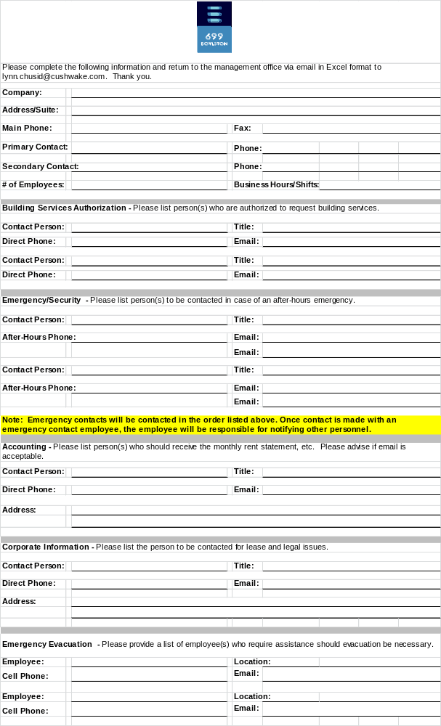

Section 18 - Emergency Procedures and Evacuation

Building Life and Safety Systems Overview
699 Boylston Street is equipped with a Class A, UL listed fire alarm system. All common areas are monitored and supervised via hardwired peripheral devises such as pull stations, smoke detectors and audible and visible horn strobes. All devices are connected to the Fire Command Center and are monitored 24/7 by a UL listed monitoring Station and the Boston Fire Department.

Fire Alarm
When heat or smoke is detected in the building, an alarm will be transmitted to the Boston Fire Department and Fire Command Center. An alert tone, four short beeps repeated 3x’s will sound on all floors. Further, the following recorded voice message will be heard:
“Attention please: The signal tone you have just heard indicated a report of an emergency in this building. If you floor evaluation signal sound after this message, walk to the nearest stairway and leave the floor. While the report is being verified, occupancy on other rfoorsshoul await further instructions

Evacuation
- If evacuation of your floor is necessary, you will hear an evacuation tone over the public address system. The evaluation tone is a slow “whooping” tone that will initially be heard on the floor of incident, the floor above and floor below.

- Enter the nearest evacuation stairway and proceed down until you exist the building.

- Stay to the right when in the stairway to allow incoming emergency personnel to use the left side.

- Once outside the building, please move quickly to a predetermined location at least 500’ from the building to meet your fellow workers and guests. Individuals located on floors NOT affected by the alarm should remain on their floor and await specific instructions over the public address system. In the event of a fire, complete evacuation may not be necessary. A full-scale evacuation has the potential to overcrowd the stairways and cause unnecessary injury.

Stairwells

- Two exist stairwells, an East stairwell and a West stairwell, run the entire height of the building, are accessible from all floors, and exit out of the building. Stairwell door are unlocked during an alarm condition to allow re-entry to any floor. If your path to a safe floor or the lobby is blocked, be prepared to leave one stairwell and cross over to the other.

Elevators
- Elevators should not be used in any evacuation of the building
- Elevators will not respond to the call button during a fire situation.
- Elevators are programmed to automatically return to, and remain at, the first floor or go to an alternate floor depending on the location of the alarm
- Elevators will be controlled by the first department.
- All elevators, the lobby concierge desk and the fire command room are linked via a two-way communication conveying information to passengers.

Physically Challenged

- If is important to keep the management office and security desk informed if there are any employees who are physically challenged and may require assistance during an evaluation. It is suggested that those who required assistance be assigned a buddy to escort to them to the stairwell. This sheet should be updated as needed. Persons requiring assistance are advised to to to to nearest stairwell.

SUMMARY:
- All occupants are to take the nearest stairwell if evacuation is required.
- Please maintain a safe distance from the building and await instructions from Property Management or the Boston Fire Department. In the event of conflicting information, instructions from the Boston Fire Department will govern in the event of an emergency.
- Please note that the Property Management Personnel are not authorized to reset or silence a fire alarm until the Boston Fire Department arrives and verifies the alarm.

Should you have any questions regarding the contents of this Handbook, please contact the Building Management Office. If there is a discrepancy between the contents of this manual and your Lease, the Lease language will prevail.

If you would like any documents sent to you by e-mail (i.e. Recycling Flyer, Tenant Contact Form), please contact the management office.

We appreciate your tenancy at 699 Boylston Street and strive to ensure a comfortable and productive work environment for all. Your suggestions and comments are welcome.

